# Business Model

## Value Proposition Model

As a starting point, we identified two different customer segments and created a Value Proposition for each of them. The first model in Figure 1 contains the Value Proposition of Restaurant Customers (mass market). We define Restaurant Customers as persons who are usually the restaurant visitors. Figure 2 contains the Value Proposition for Restaurant Businesses. They are Restaurant Owners or franchises.

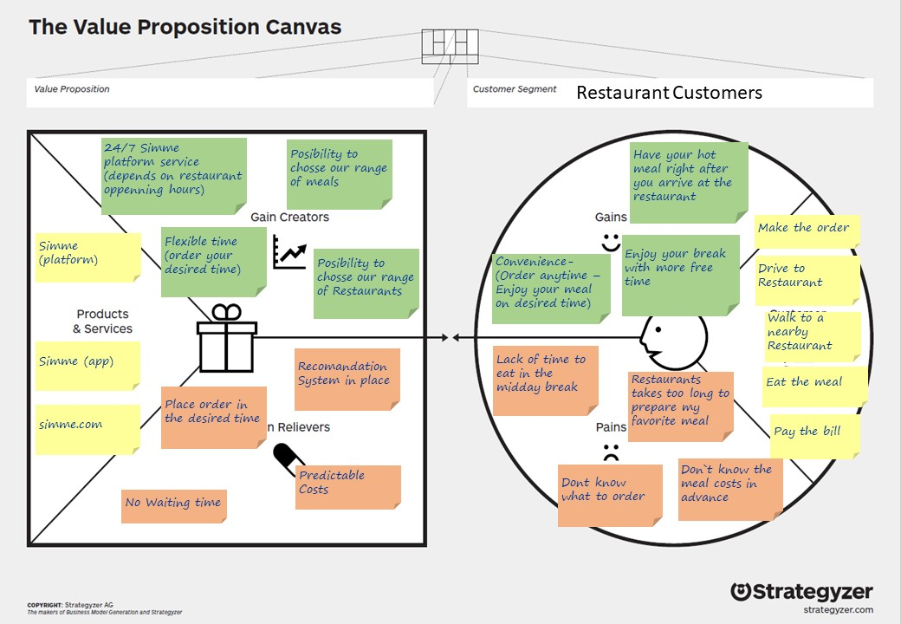

Figure : Restaurant Customers

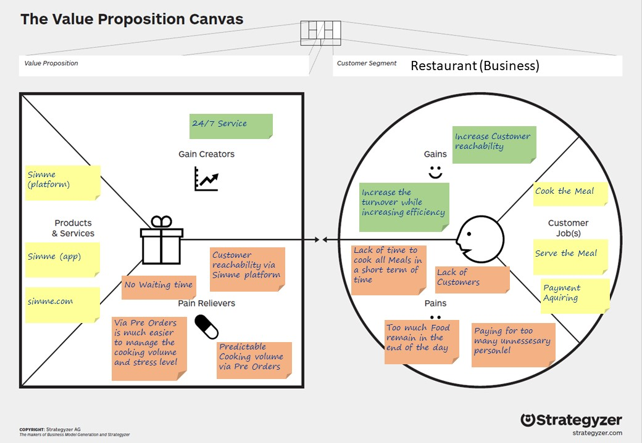

Figure : Restaurant Businesses

Figure : Business Model Canvas

## Description of the nine Canvas Model Parts

**Customer Segments**

Identifying Customer Segmentation is the first and one of the essential steps in the Business Model Canvas. We have identified the following two Customer Segments: Restaurant Customers: These customer segments include enterprise customers and private customers that are willing to eat during the day or even in the dinner. These customers, however, would place orders and pay the invoice in advance for their desired drinks and meals to benefit from various services that Simme.com offers such as unlimited access to different kinds of Restaurants and locations.   
Restaurant Businesses: These are customers that own a Restaurant or franchises a Restaurant Chain.

**Value Proposition**

The value proposition enables us to identify unique offers that will attract customers to select our services instead of a competitor.

We offer our customers the opportunity to use a wide range of Restaurants, Drinks, and Meals from the Simme platform. Given that our customers do not have enough time, especially in the midday break for lunch, our solution gives them the possibility to choose between different kinds of restaurants, drinks, meals, and locations whenever they desire.

**Channels**

Restaurant Customers have the possibility to order in advance and have their meal ready as they arrive at the destination. Restaurant Businesses have the possibility to predict their cooking due to the customer preorders Services are delivered through the application. All administrative tasks will be run online through the web platform and the app. This way, customers have access to their data, and they can also track their data usage for easy monitoring and control. All-in-all, in addition to using our channels.

**Customer Relationship**

Self-service through app and web service: this is applicable for Restaurant Customers and as well for the Restaurant businesses. The customers can register, preorder the desired drinks, meals, restaurant and location. The process is very fast and convenient, thanks to the user-friendly interface on the app and webpage. All customers will have the opportunity to enter their data such as favorite dishes, a favorite restaurant, favorite locations, allergies if they apply etc.

**Key Partners**

We have identified two different key partners.

Restaurants and Franchisees are classified as one of our key partners. The platform itself is tightly connected with Restaurants respectively cooperation between our platform and the Restaurants. As the second Key Partner, we have identified organizations with Long Term Contracts who are willing to cooperate with as an advertising solution. In general, we categorize our key partners as *optimization and economy of scale* and *acquisition of appropriate resources and activities*.

**Key Activities**

One of our identified key activities is the development and maintenance of the IT platform. This is important as the main channels to communicate with our customers are our web site and the app. To be recognized by the people, marketing is a key activity.

**Key Resources**

To be able to communicate with our customers the primary resource is the IT Infrastructure which ensures the well functioning of the platform. Employees are essential in the background to keep everything going.

**Cost Structure**

As costs, we have the IT Infrastructure, development and maintenance. To acquire new customers, we apply various marketing activities and strategies. Other relevant costs include administration and salaries for the employees.

**Revenue Stream**

Commission on each order are used to generate revenues. Different models will be available such that customers have options depending on their budget. The second revenue stream will be through our long term contracts for Ads selling in our platform.